**Table of contents**

Catalog

1. HTML 2

● What is HTML? 2

● Head 2

● Title 2

● Body 2

● Heading 2

● Semantic Meaning 3

● Image Tag 3

● Unordered List 4

● Order List 4

● List item 4

● Table 4

● Form 4

● Input 4

● HTML Input Types 4

1. Button 4

2. Checkbox 4

3. Color 5

4. Date 5

5. Datetime-local 5

6. Email 5

7. File 5

8. Month 5

9. Number 5

10. Password 5

11. Radio 6

12. Range 6

● Select Drop-down List 6

● Options 6

● Break Line 6

● Div 6

Image 2 Table,Heading Image 7

Image 3 List and Paragraph 7

Image 4 Iframe,Input and Form 8

Image 5 Audio,Video and Select 8

Image 6 Input Types 9

2 CSS 9

■ What is CSS? 9

■ Three Ways to Insert CSS 9

1. External CSS 10

2. Internal CSS 10

3. Inline CSS 10

● body 10

● image 10

● a 10

● button 10

● p 10

Image 7 CSS h1,a,p button tags 11

3. SAAS 14

■ Sass Variables 16

■ Sass Nested Rules 16

■ Sass @import 16

■ Sass @extend Directive 16

4. Bootstrap 16

● What is Bootstrap? 16

● Containers 16

● Cards 17

● Collapsible 17

● Carousel / Slideshow 17

● Pagination 17

● Spinners 17

● Progress Bar 17

● Badges 17

● Table 17

Source code Link 21

# 1. HTML

## What is HTML?

HTML stands for Hyper Text Markup Language. HTML is the standard markup language for creating Web pages.

## Head

Defines information about the document such as its title and links to style sheets.

## Title

Defines the title of the document, shown in the browser's title bar or page tab.

## Body

Defines the document's body, containing all content visible to the user.

## Heading

Define HTML headings, with <h1> being the highest level and <h6>

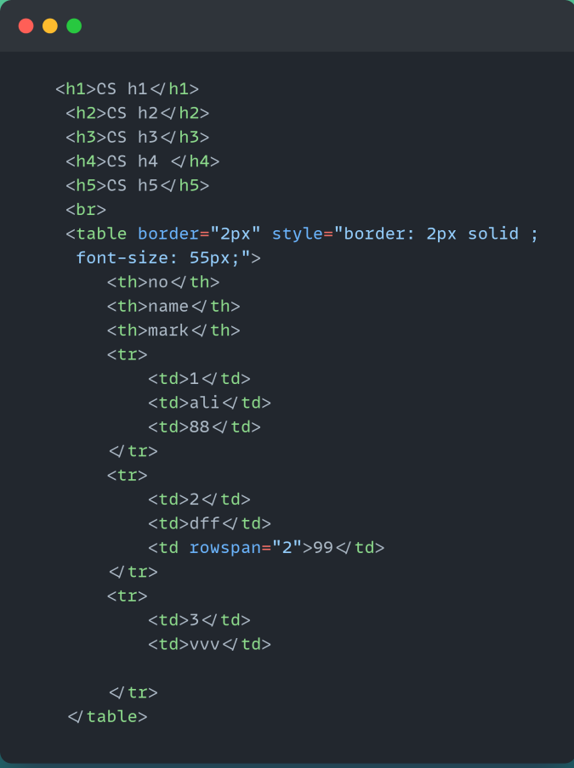

**Image 1** Heading and table

**Output**

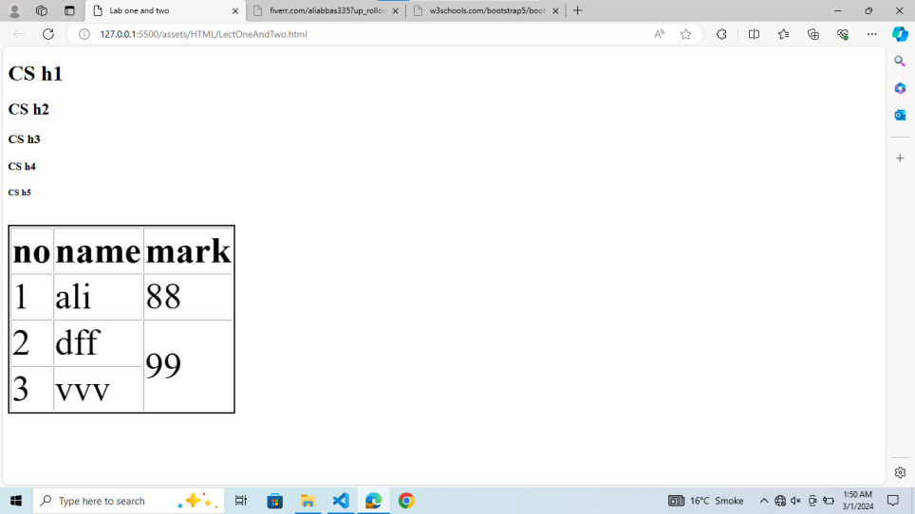

## Semantic Meaning

Each HTML element carries semantic meaning, aiding accessibility and search engine optimization. For instance, **<header>** ,**body** and **<footer>** denotes concluding information.

## Image Tag

Embeds an image in the document.

## Unordered List

Defines an unordered list.

## Order List

Defines an ordered list.

## List item

Defines a list item within <ul> or <ol>.

## Table

The **<table>** element in HTML is used to define a table**.<tr>** (Table Row): Defines a row within the table.

**<th>** (Table Header Cell): Defines a header cell within a row. These cells are typically bold and centered.

**<td>** (Table Data Cell): Defines a standard data cell within a row.

## Form

Defines an HTML form for user input.

## Input

Defines an input control, such as a text field or button, within a form.

## HTML Input Types

Here are the different input types you can use in HTML

### Button

This creates a clickable button. It's often used to trigger a JavaScript function or submit a form.

### Checkbox

This allows users to select one or more options from a list of choices by checking boxes.

### Color

This input type displays a color picker dialog, allowing users to choose a color.

### Date

This provides a date picker interface for selecting dates. The format of the selected date varies depending on the browser's locale settings.

### Datetime-local

Similar to the "date" input type, but also allows users to select a time along with a date.

### Email

This input type is used for collecting email addresses. It typically provides validation to ensure that the entered text is in a valid email format.

### File

This allows users to select one or more files from their device for uploading to a server.

### Month

This input type allows users to select a month and year, typically displayed as a drop-down menu or a calendar interface.

### Number

This provides a field for entering a numerical value. It may also include validation to ensure that only numeric input is accepted.

### Password

This hides the entered text, typically displaying asterisks or dots instead of the actual characters. It's commonly used for collecting sensitive information like passwords.

### Radio

This allows users to select only one option from a list of choices. Unlike check-boxes, which allow multiple selections, radio buttons are mutually exclusive.

### Range

This provides a slider control for selecting a value within a specified range. It's often used for selecting a value from a continuous range, such as volume or brightness controls.

## Select Drop-down List

Defines a drop-down list within a form.

## Options

Defines an option in a drop-down list.

## Break Line

Inserts a single line break.

## Div

The <div> element is used as a container for other HTML elements.

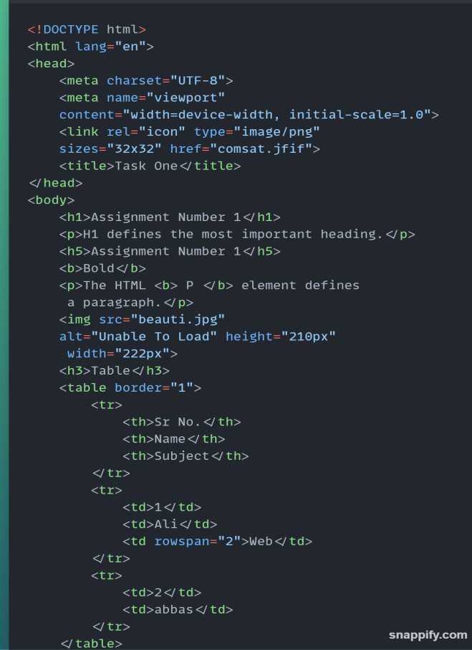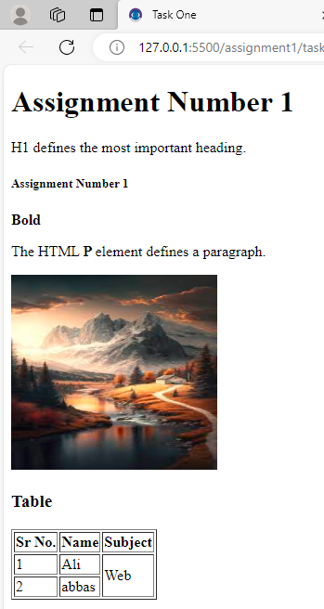

**Image 2**Table,Heading Image

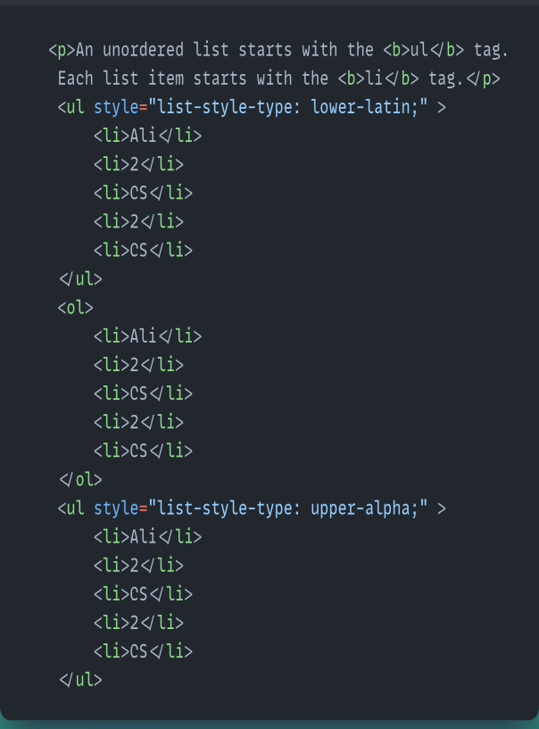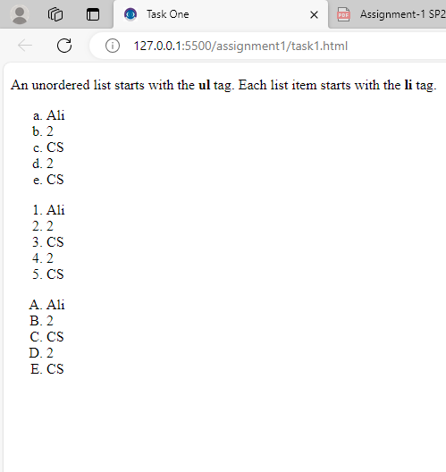

**Image 3**List and Paragraph

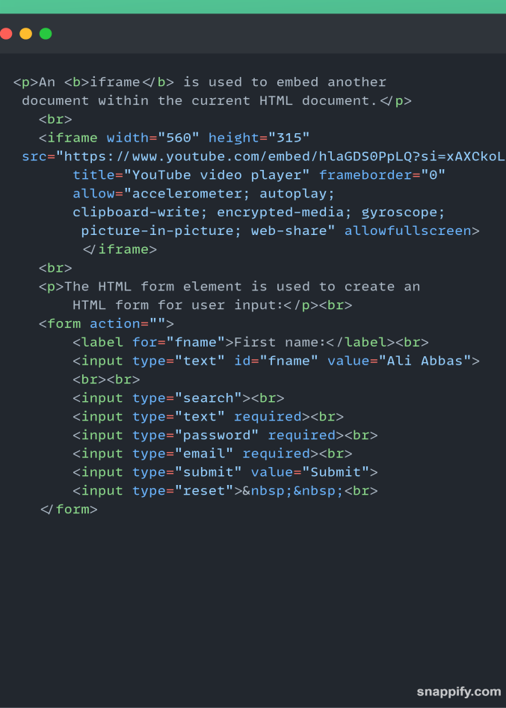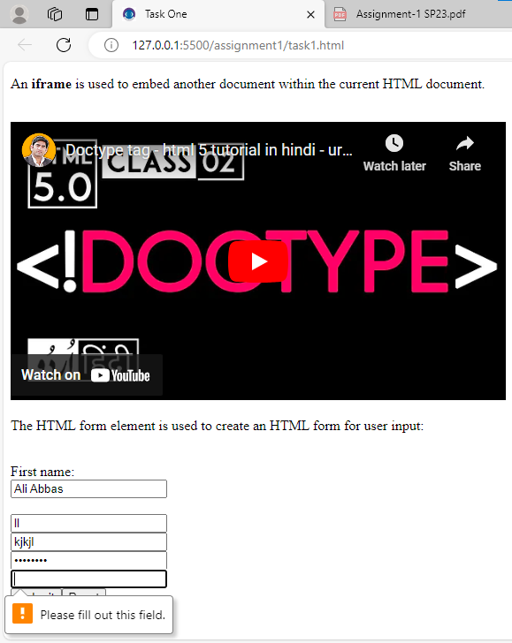

**Image 4** Iframe,Input and Form

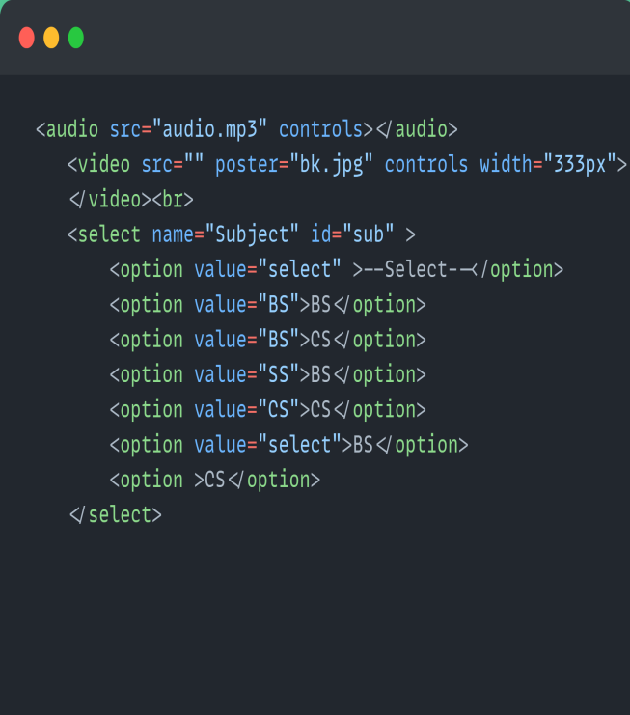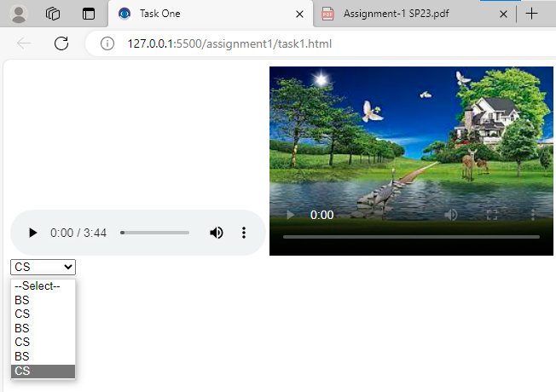

**Image 5**Audio,Video and Select

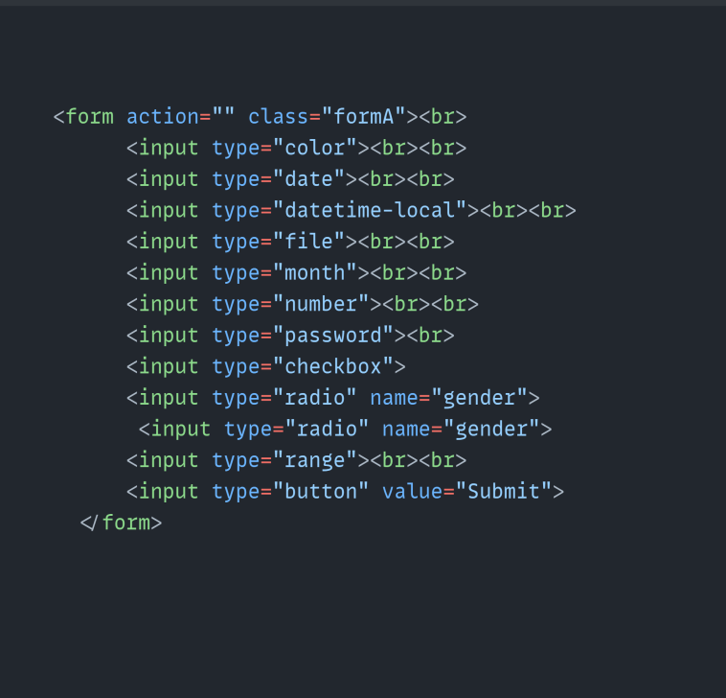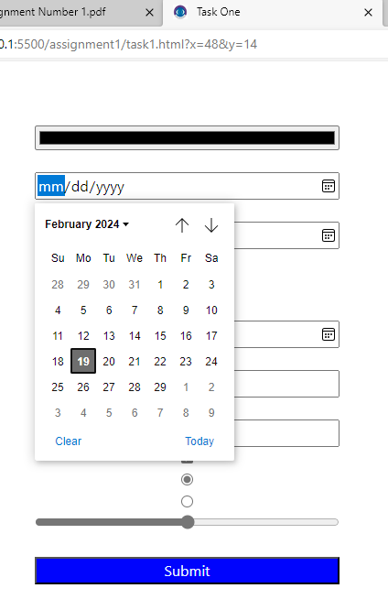

**Image 6**Input Types

# 2 CSS

## What is CSS?

CSS is the language we use to style an HTML document. CSS describes how HTML elements should be displayed.

## Three Ways to Insert CSS

There are three ways of inserting a style sheet:

### External CSS

### Internal CSS

### Inline CSS

### body

This selector targets the <body> element in HTML, which represents the content of an HTML document. Styles applied to the body selector affect the entire page.

### image

Image elements are used to display images on web pages.

* a

This selector targets anchor (<a>) elements in HTML. Anchor elements are commonly used to create hyperlinks on web pages. With CSS, can style these links to change their appearance, such as color, text decoration, and hover effects.

### button

This selector targets <button> elements in HTML. Buttons are interactive elements often used to trigger actions or submit forms on web pages.

* p

This selector targets <p> elements in HTML, which represent paragraphs of text.

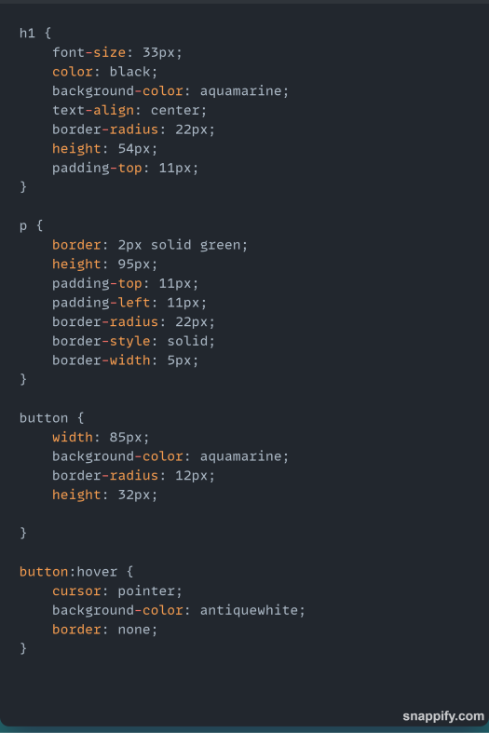

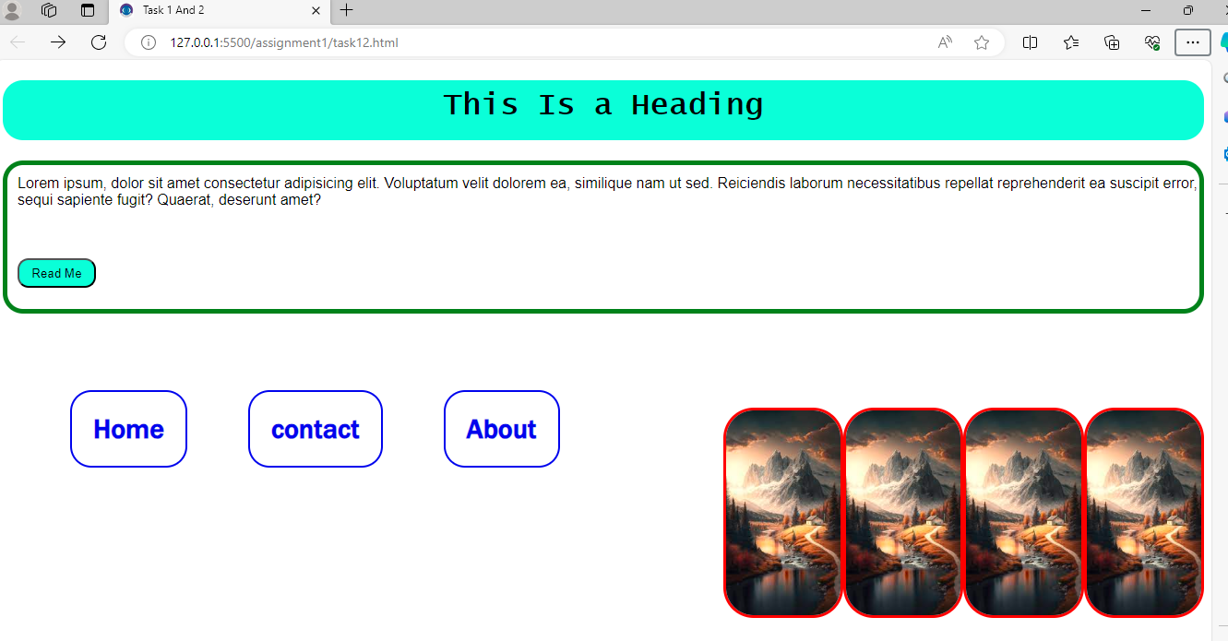

**Image 7** CSS h1,a,p button tags

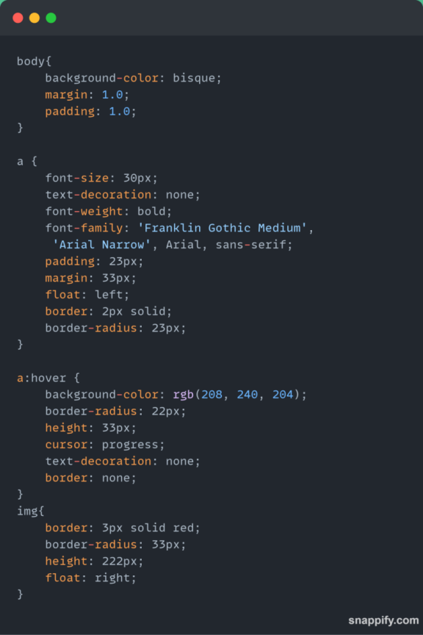

**Image 8** CSS code

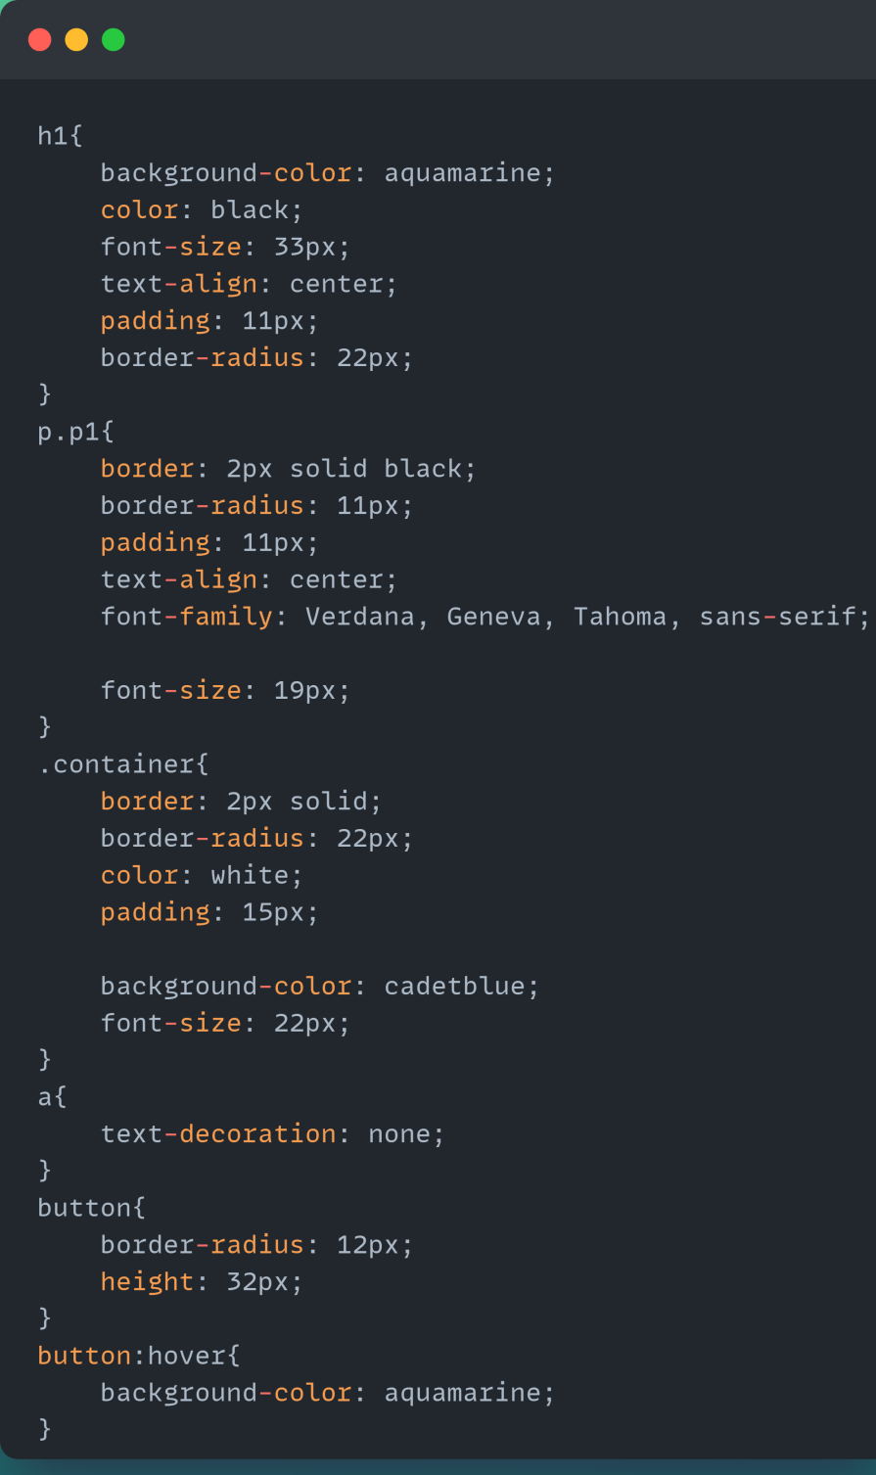

**Image 9** CSS

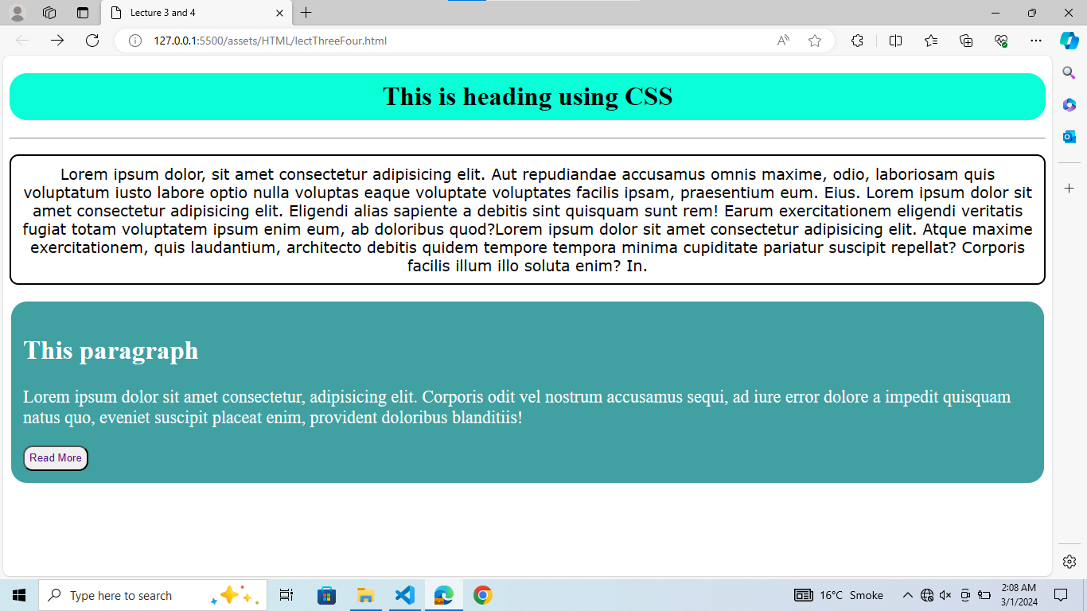

**Image 10** Output container

# 3. SAAS

1. Sass stands for Syntactically Awesome Style-sheet.
2. Sass is an extension to CSS
3. Sass is a CSS pre-processor
4. Sass is completely compatible with all versions of CSS
5. Sass reduces repetition of CSS and therefore saves time.

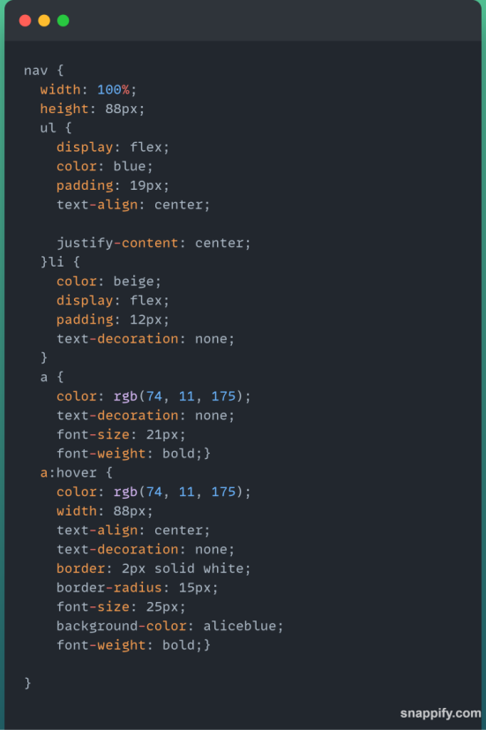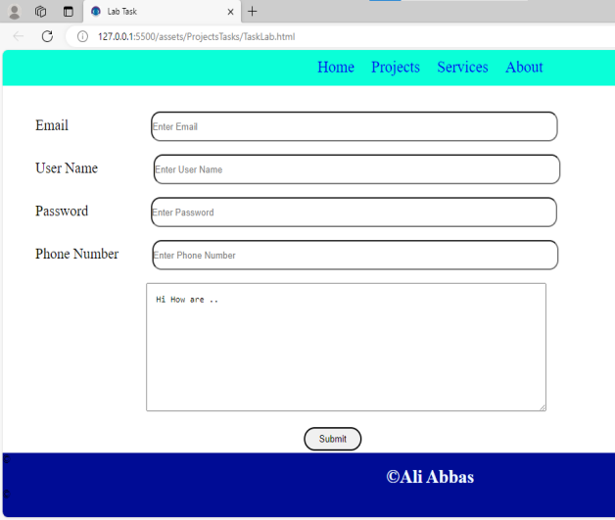

**Image 11** SAAS NavBar

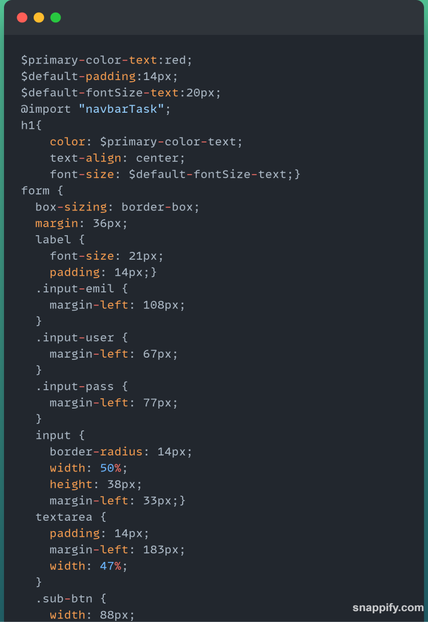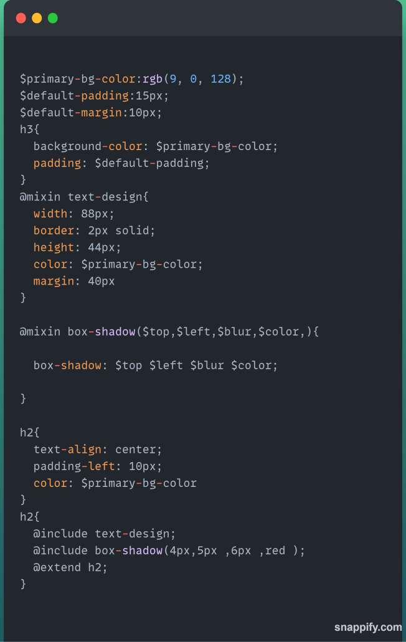

**Image 12** SAAS variable,mixin,extends

## Sass Variables

Variables are a way to store information that you can re-use later.

## Sass Nested Rules

Sass lets you nest CSS selectors in the same way as HTML.

## Sass @import

One way to write DRY code is to keep related code in separate files.

Sass Mixins

The @mixin directive lets you create CSS code that is to be reused throughout the website.

The @include directive is created to let you use (include) the mixin.

## Sass @extend Directive

The @extend directive lets you share a set of CSS properties from one selector to another.

The @extend directive is useful if you have almost identically styled elements that only differ in some small details.

# Bootstrap

## What is Bootstrap?

Bootstrap is a free front-end framework for faster and easier web development

Bootstrap includes HTML and CSS based design templates for typography, forms, buttons, tables, navigation, modals, image carousels and many other, as well as optional JavaScript plugins

Bootstrap also gives you the ability to easily create responsive designs.

## Containers

Containers are used to pad the content inside of them, and there are two container classes available.

The **.container** class provides a responsive fixed width container.

The **.container-fluid** class provides a full width container, spanning the entire width of the viewport.

## Cards

A card in Bootstrap 5 is a bordered box with some padding around its content. It includes options for headers, footers, content, colors, etc.

## Collapsible

Collapsible are useful when you want to hide and show large amount of content.

## Carousel / Slideshow

The Carousel is a slideshow for cycling through elements.

## Pagination

If you have a web site with lots of pages, you may wish to add some sort of pagination to each page.

## Spinners

To create a spinner/loader, use the .spinner-border class.

## Progress Bar

A progress bar can be used to show how far a user is in a process.

## Badges

Badges are used to add additional information to any content.

## Table

A basic Bootstrap 5 table has a light padding and horizontal dividers. The .table class adds basic styling to a table.

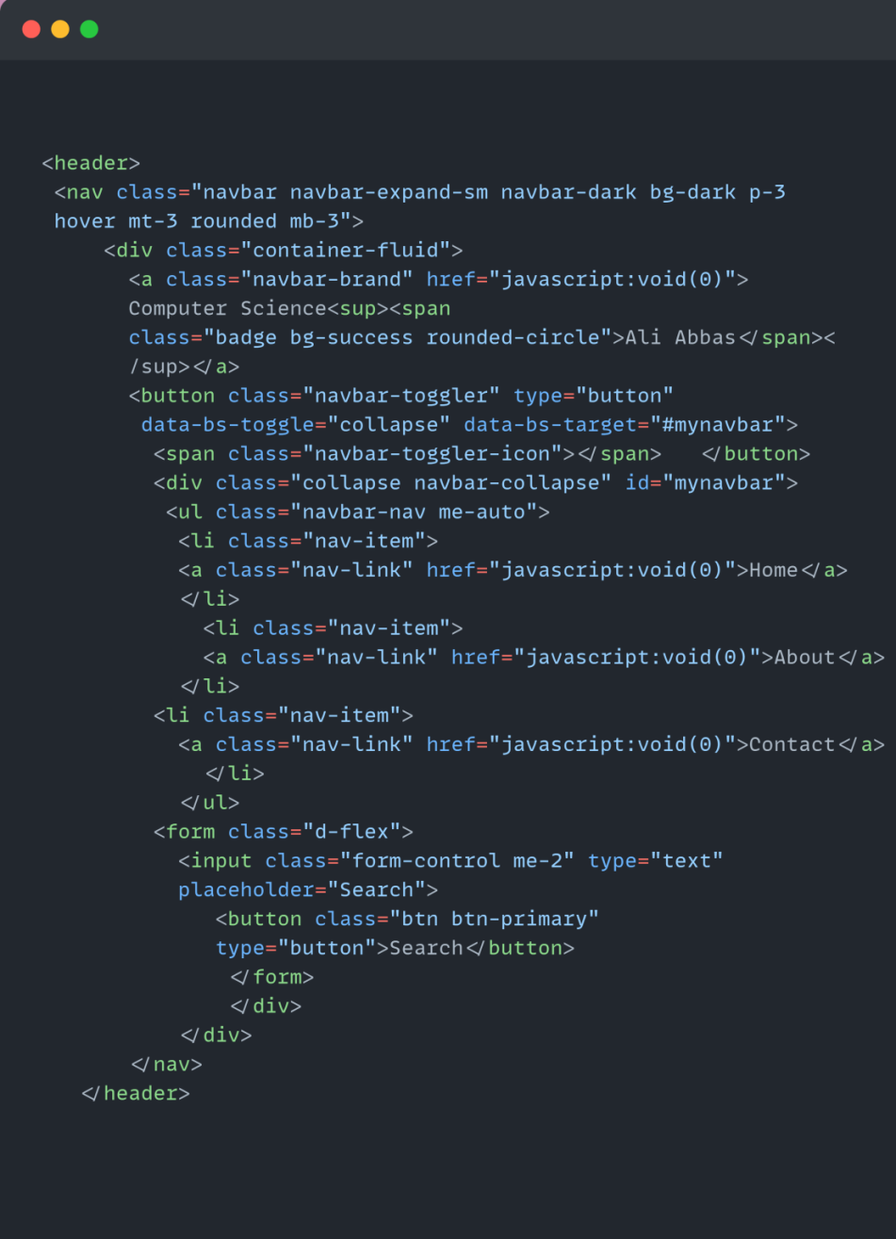

**Image 13** NavBar Bootstrap

**Output**

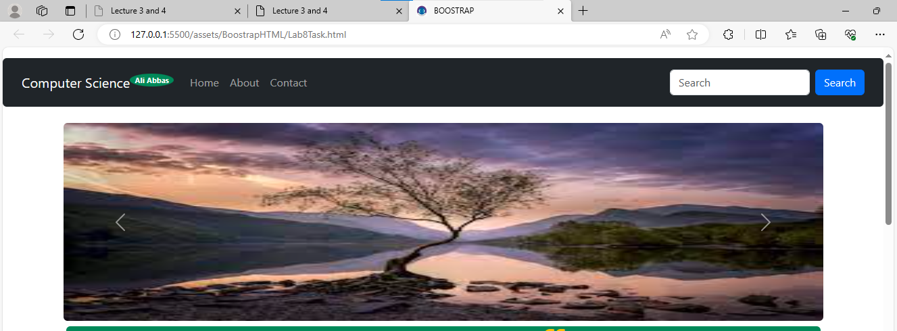

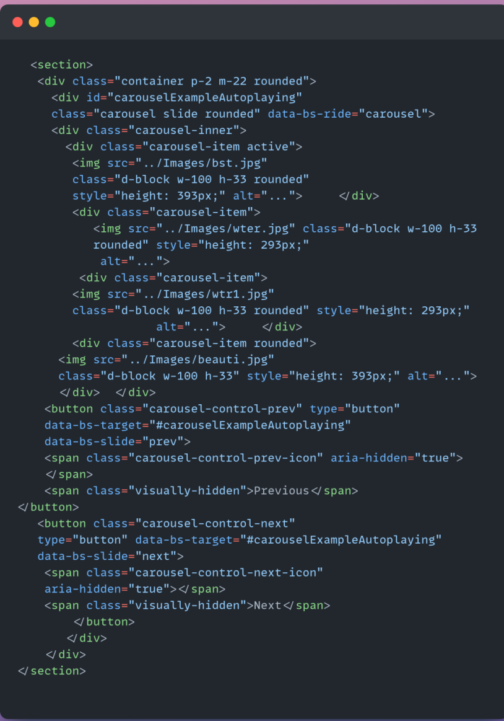

**Image 14** Slide/Carousal

Output

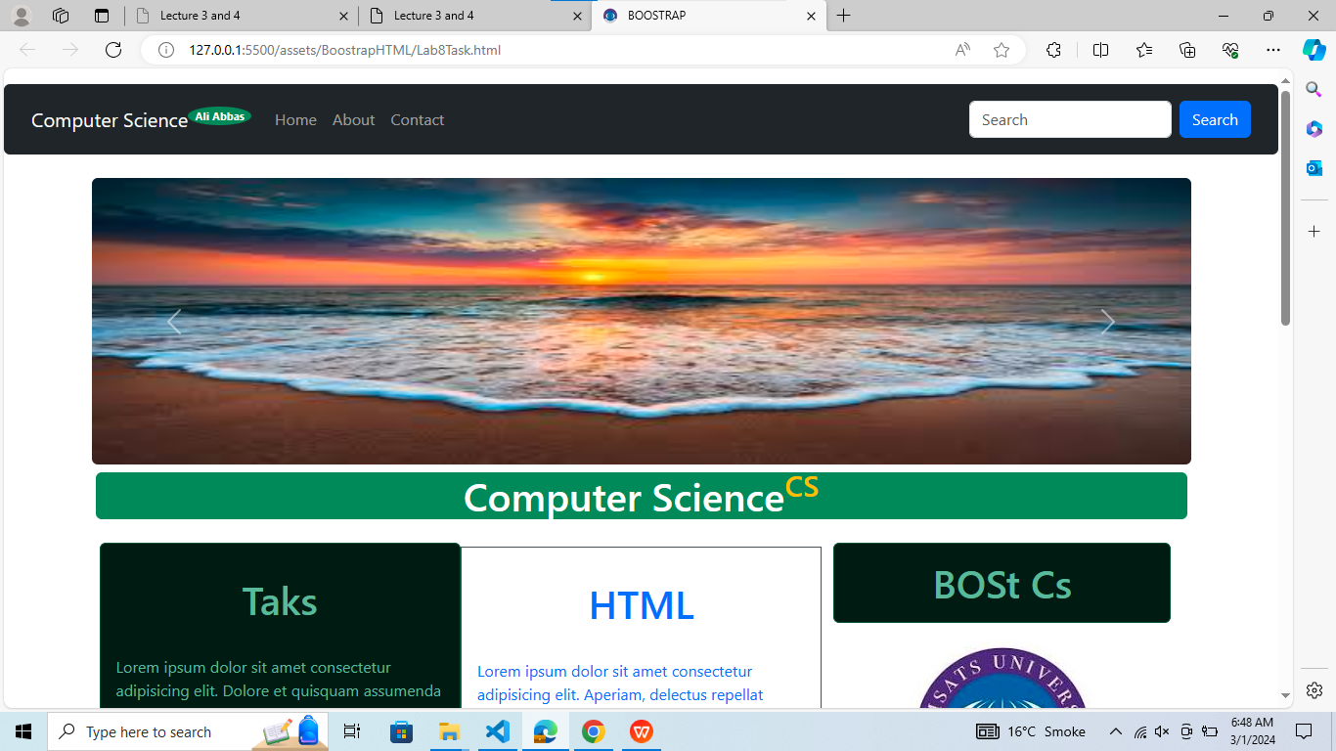

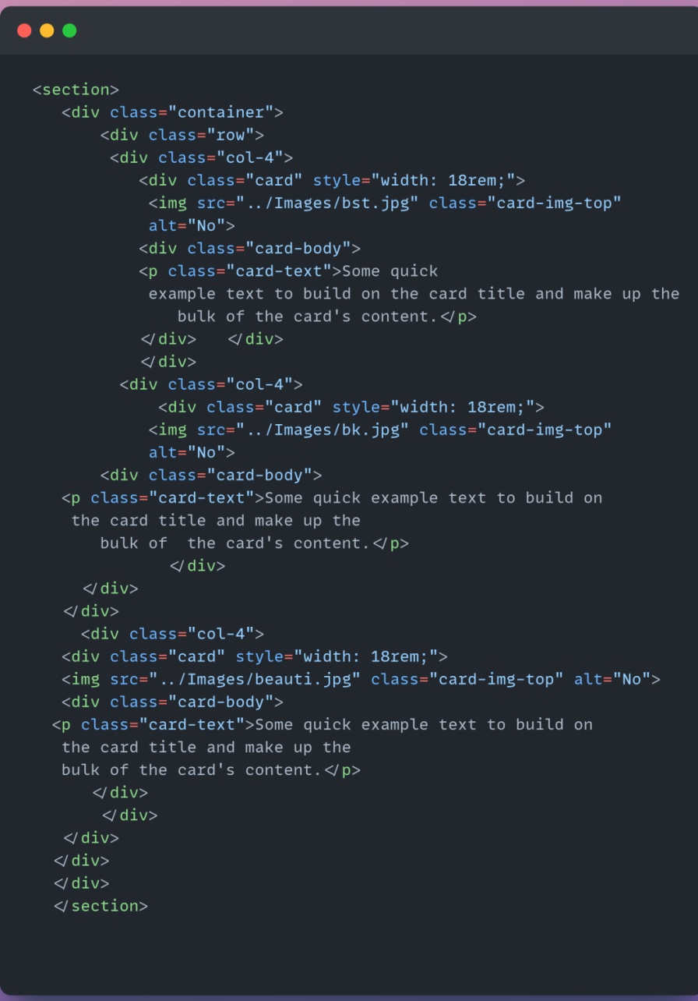

**Image 15** Card

Output

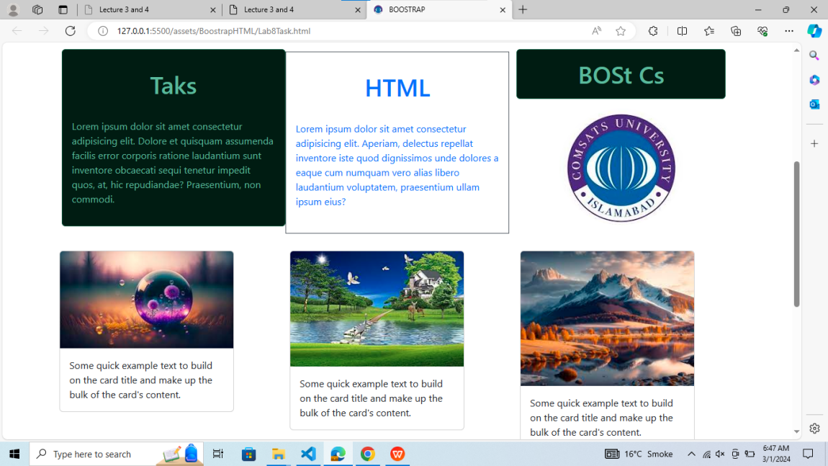

# Source code Link

<https://github.com/Aliabbas9870/Web_Technology_Fa21_BCS_034>